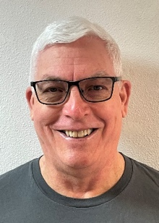
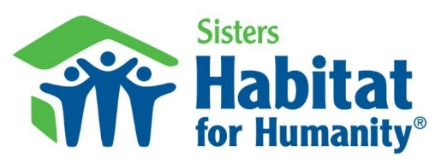
As Sisters Habitat enters its 31st year, I’d like to acknowledge the contributions and dedication of the staff, Board of Directors, volunteers, donors and partners in making a difference in the Sisters Community. It truly is an amazing story for our small town.
Incredibly, Sisters Habitat has constructed 72 affordable homes, completed eleven home repairs and averaged 2-3 new affordable homes per year providing safe, stable, affordable housing to hardworking people who live, work and contribute to the fabric of our community. Our homeowners provide sweat equity, mortgage payments and many continue to volunteer in support our programs.
Sisters Habitat could not accomplish our mission without the continued support of our dedicated partners that provide at cost or reduced services and materials that reduces our cost to build homes allowing more potential homeowners for the affordable housing we provide. I would especially like to acknowledge our local partners: Ace Hardware, Action Air, Canyon Electric, Hoyts, Sweeney Plumbing and many other local businesses. Also, the Heart of Oregon Corps YouthBuild has been invaluable in providing the skills and labor to build five homes, including two in 2021.
Our volunteers are the lifeblood or our organization. The majority of the people who you see at the building sites, ReStore or Thrift Store are volunteers with many more volunteers working behind the scenes, serving on committees, the Board of Directors, as family partners and administrative assistants. In 2021, Sisters Habitat had over 200 volunteers that volunteered over 23,000 hours, equating to over 12 man-years of labor. These volunteers work selflessly and tirelessly in support of our Vision and Mission.
I would also like to acknowledge the financial support we receive from our faithful donors. Our year-end $30,000 matching challenge raised over $67,000 and was generously funded by Melanie Nelson, an anonymous donor and the Habitat Board of Directors.
Coordinating and supporting all of this effort is our incredible hardworking staff. Their resilience and dedication to the mission of Habitat is exemplary. Thank you for all that you do to make this a better place.
Moving forward in 2022, we will be focusing on:
- Completing the remodel of a home we bought back for the Chew family
- Completing new homes in the ClearPine neighborhood for the Johns, Mantel and Harris families and starting construction on two new homes.
- Moving forward with infrastructure improvements in Village Meadows and purchasing lots in the Woodlands development and moving the offices to a new location across from Ace Hardware.
It is an honor to serve such a great organization that brings people together to build homes, communities and hope.
Bob Buchholz, Board President
P.S. Many thanks to outgoing members of the Board of Directors: Ellie Hammond, Kristi Amsberry, Connie Cross, and Roger Fairfield.

Future Homeowners
Partner with Sisters Habitat

S
isters Habitat for Humanity believes that everyone deserves a decent place to live.
Each family selected into our program must earn a total of 500 sweat equity hours. Currently, eight families are earning their sweat equity. Some hours may be donated by friends, family and volunteers. Everyone must work on their own home, allowing each future homebuyer to have true ownership in the process before they sign the mortgage.

Meet the Homebuyers Selected in 2021
Holly and Elia Mapusaga are Sisters Habitat’s newest future homebuyers. Holly has lived in Sisters since 2001 and Elia since 2018. The couple met in Samoa where Holly was doing missionary work and Elia was a pastor. Between the two of them, they have 7 adult children and one in high school. Holly struggles with health issues, but when she is feeling good, she enjoys swimming, reading, and crafts. Elia enjoys building furniture, cooking, and landscaping. They say that buying an affordable Habitat home allows them to stay in Sisters and gives them financial stability.
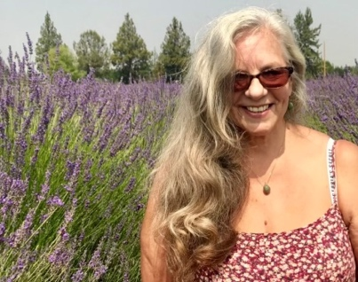
Toni Del Guidice was first introduced to Sisters during her high school days when her family came from the Willamette Valley to ski and play in the snow. She always had a dream that she would come back to Sisters to live, and in 2000, she moved here to be closer to her three grown children and one grandson who live in the area. When asked about her Sisters Habitat experience as a volunteer, and as a selected homebuyer, she said that she loves the Habitat program and enjoys the camaraderie of everyone working together and helping each other. Toni is also excited about working toward her future Habitat home. “This is making it so I can make it and contribute to the community!”

